Typical Materials for Aircraft Oxygen Cylinders

Aircraft oxygen cylinders need to be strong, lightweight, and compatible with high-pressure oxygen. The most common materials are:

High-Strength Steel Alloys (e.g., 4130 Chrome-Moly Steel): Advantages: Excellent strength, well-understood material properties, relatively inexpensive compared to some alternatives. Disadvantages: Heavier than aluminum or composite options. Susceptible to corrosion if not properly treated (though typically coated internally). Aluminum Alloys (e.g., 6061-T6): Advantages: Lighter than steel, good corrosion resistance. Disadvantages: Lower strength than steel, so requires thicker walls for the same pressure rating, or specific treatments. Composite Materials (e.g., Carbon Fiber with a liner): Advantages: Very lightweight, high strength-to-weight ratio. Disadvantages: More expensive, more complex manufacturing, potential for damage if not handled carefully. The liner can be metal or plastic. Titanium Alloys: Advantages: Excellent strength-to-weight ratio, very good corrosion resistance. Disadvantages: Very expensive, difficult to manufacture. Not typically used in commercial aircraft due to cost. Material Properties & Ultimate Tensile Strength (UTS)

Here’s a table with approximate values. Keep in mind that specific alloys and heat treatments will change these values:

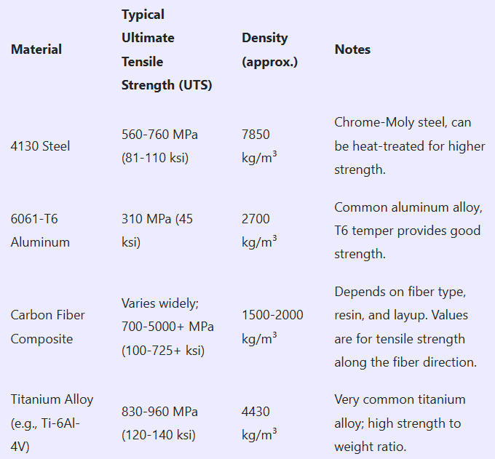

Specific Alloy/Grade: Always consult the material specification for the exact alloy and heat treatment used in the cylinder’s construction. Material properties can vary significantly. Design Factor/Safety Factor: Aircraft components are designed with a significant safety factor. This means the actual stresses in the cylinder during operation will be much lower than the UTS. Typical safety factors might be 1.5 to 4, or even higher, depending on the criticality of the system and regulatory requirements. Consult relevant aviation standards (e.g., FAA regulations, EASA regulations) for guidance on safety factors. Operating Pressure: Aircraft oxygen systems typically operate at relatively high pressures (e.g., 1800-2200 psi, or even higher for some emergency systems). The design pressure is a critical parameter. Fatigue: Cylinders are subject to pressure cycling throughout their lifespan. Fatigue strength is an important design consideration, especially for metallic cylinders. Periodic inspections and testing are mandated to detect any signs of fatigue damage. Thin-Walled Pressure Vessel Approximation

The thin-walled pressure vessel assumption simplifies stress calculations. The general rule of thumb is that a vessel can be considered “thin-walled” if the ratio of the inner radius (r) to the wall thickness (t) is greater than 10:

r/t > 10 If this condition is met, you can use the following formulas:

Hoop Stress (Circumferential Stress): σ_h = (P * r) / t Where:

σ_h is the hoop stress (stress acting along the circumference of the cylinder) P is the internal pressure r is the inner radius t is the wall thickness Longitudinal Stress (Axial Stress): σ_l = (P * r) / (2 * t) Where:

σ_l is the longitudinal stress (stress acting along the length of the cylinder) Calculating Thickness and Radius

Choose a Material and Determine UTS: Select a material and look up its ultimate tensile strength (UTS).

Determine Operating Pressure (P) and Safety Factor (SF): Find the maximum operating pressure of the oxygen system. Decide on a safety factor.

Calculate Allowable Stress (σ_allowable): σ_allowable = UTS / SF

Apply Thin-Walled Formulas and the r/t ratio: You have two stresses to consider, and the condition r/t > 10.

Use the hoop stress formula because it gives the largest stress in the wall σ_h = (P * r) / t -> t = (P * r) / σ_h

Combine that with r/t > 10 or r > 10t.

You can solve for r and t with a bit of algebra. Replace t from the first equation into the second equation to get the radius: r > (10 * P * r) / σ_h 1 > (10 * P) / σ_h σ_h > (10 * P) We want to use the allowable stress, so make the hoop stress equal to the allowable stress σ_allowable = (10 * P) UTS / SF = (10 * P) SF = UTS / (10*P) So, the safety factor should be chosen so the UTS is 10 times the design pressure.

Now to calculate the thickness and radius for your cylinder, you need to assume a safety factor to calculate the radius or the thickness, and then the thickness will be calculated from the radius.

Example Calculation:

Let’s assume:

Material: 6061-T6 Aluminum (UTS = 310 MPa) Operating Pressure (P): 20 MPa (Approx 2900 PSI) Assume a Safety Factor (SF) = 2 (This is for illustration only. A higher SF is recommended for aircraft) Allowable Stress: σ_allowable = 310 MPa / 2 = 155 MPa

First, make sure that the safety factor is greater than 10 times the design pressure for a thin-walled pressure vessel 155 MPa > (10 * 20 MPa) 155 MPa > 200 MPa Based on these values, it will not be a thin-walled pressure vessel

Let’s assume the inner radius, r = 0.1 m (10 cm). Now, solve for t

t = (P * r) / σ_h t = (20 MPa * 0.1 m) / 155 MPa t = 0.0129 m t = 1.29 cm

Check the r/t condition

r/t > 10 0.1 m / 0.0129 m = 7.75 We now know that r/t is not greater than 10, so it is not a thin-walled pressure vessel

Important Considerations and Disclaimers:

This is a Simplified Analysis: Real-world cylinder design involves far more complex calculations, including stress concentrations at fittings, weld analysis (if applicable), fatigue analysis, buckling analysis, and consideration of temperature effects. FEA (Finite Element Analysis) is often used for detailed stress analysis. Regulatory Compliance: Aircraft oxygen cylinders must meet stringent regulatory requirements (e.g., those defined by the FAA, EASA, and national standards). These requirements dictate material selection, design, testing, and inspection procedures. Professional Engineering Required: Do not attempt to design or manufacture an aircraft oxygen cylinder without the guidance of qualified and experienced engineers who are familiar with the relevant regulations and engineering practices. This information is for educational purposes only and should not be used for actual design or manufacturing. Welding Considerations: If the cylinder is welded, the weld joints become critical areas. Welding procedures must be carefully controlled, and the welds must be inspected and tested to ensure they meet required strength and quality standards.